

**Zachary Davids 100796282**

**User Guide**

**Introduction**

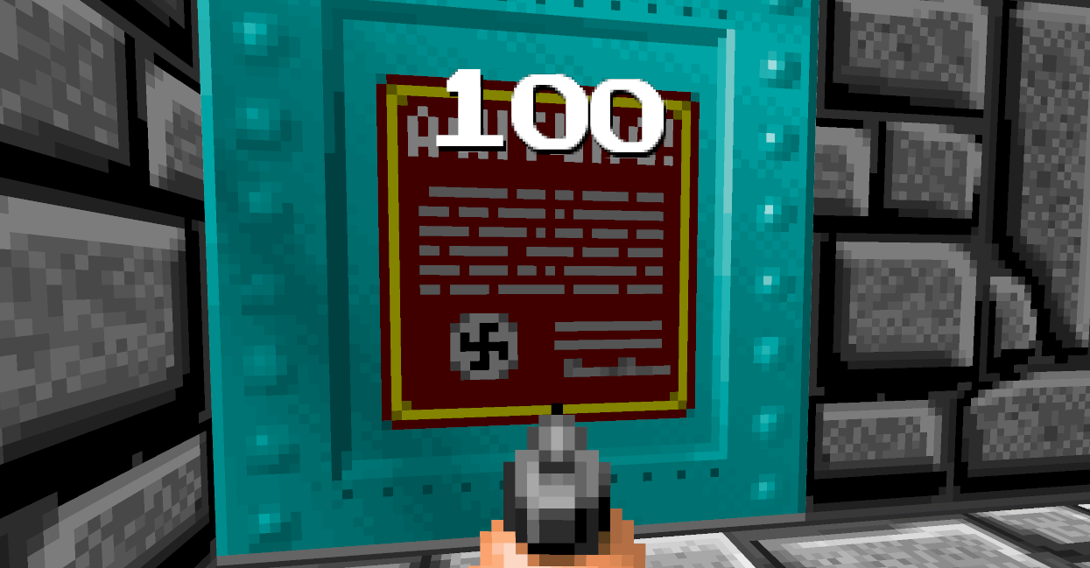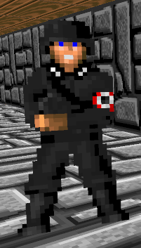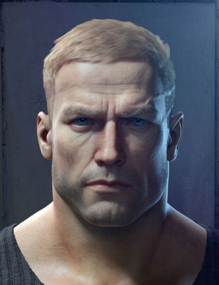Your name is William Blazkowicz, an American soldier assigned to assassinate Adolf Hitler. It is April 30th 1945 and you must make your way through the Wolf’s Lair, opening doors, shooting all Nazis in your path, and most importantly, surviving long enough in order for you to reach Hitler’s private bunker to complete your mission.

**Installation**

Installation is quick and easy on a Windows PC, and involves only the extraction of the contents of the provided ZIP file to the directory of your choice, followed by opening the solution file located within in Visual Studios 2013.

**Start Up**

After opening the solution file in Visual Studios 2013 all that is needed to run the game is to start the program in the Local Windows Debugger (F5). This will launch a new Windows console and the window running Wolfenstein!



**Rules, Interactions and Play**

The user is able to control the camera using the mouse and using the keyboard’s WASD keys the user is able to move forward and backwards and strafe left and right in relation to the camera’s view direction. By pressing the left-mouse button the user is able to shoot off rounds of his pistol in the camera view direction. Using the special key E, the user is able to open doors which will stay open for three seconds before automatically closing. Finally upon getting frustrated, the player may rage quit by hitting the Escape key which will immediately result in the game closing and the Nazis winning World War II (though you wouldn’t let that happen ;)).

The objective of the player is to progress through the two levels provided without dying. The user will start on level one, and will be confronted with various challenges in the form of Nazi soldiers which must be shot anywhere on their body three times until they are killed.



Upon entering line of sight of one of these soldiers they will automatically approach the user until they are within shooting range and will then open fire. If the user attempts to run away, the enemies will follow, even opening doors until they are able to get back within firing range. During level progression it is inevitable that the user takes damage, so spawned in pre-determined locations they will be able to find medkits that will restore 30 hit points up to a maximum of 100 health.

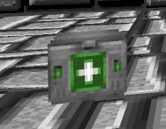

Once the player opens the magic door, the current level will end, and the next level will begin.

So young Padawan, now that you know the basics it is up to you to open doors and shoot Nazis. Before you start, remember to save medkits for when your hit points are critically low, and that everything must be taken within moderation – even Wolfenstein.

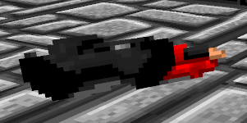

**Levels and Episodes**

Included in the Wolfenstein base game are two basic levels, each providing a slightly different layout of an area 32 squares length by 32 squares in height. The player is able to progress from the first level to the second level by finding the correct door. Upon opening this door the user’s hit points will be restored and be teleported to the next level. Expect additional levels in upcoming DLC packages!

**Scoring**

The current score system consists solely on the players progress through the various levels, and bragging rights are rewarded accordingly, for example, Tim may brag to his friends “Hey, I got to level two in Wolfenstein last night!” shaming his friend Liam, who obviously did not read the User Guide and still can’t quite figure out how to open doors. Currently there is no way to save your progression from level to level, and upon a game over (hit points reaching zero) the user will restart back at level one. This is intended to provide a greater challenge.